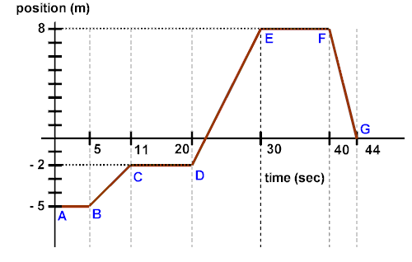
On this graph, positive positions and directions of travel are considered to be South.

- During which time interval (AB, BC, CD, DE, EF, FG) was the cart traveling at its greatest speed? Explain how you know.

- During which time interval (AB, BC, CD, DE, EF, FG) was the cart traveling at its least (nonzero) speed?

- During which time interval(s) (AB, BC, CD, DE, EF, FG) was the cart at rest?

- During which time interval(s) (AB, BC, CD, DE, EF, FG) did the cart travel in a negative direction?

- What was the cart's speed at 6 seconds?

- What was the cart's speed at 22 seconds?

- What was the cart's speed at 35 seconds?

- What was the cart’s average speed for the entire 44 second interval?

- Describe the motion of the cart through the entire 44 second interval.

